1. **sex-vs-earn**

## Load the ggplot2 package

library(ggplot2)

theme_set(theme_minimal())

## Set the working directory to the root of your DSC 520 directory

setwd("C:/Users/ragun/Documents/GitHub/dsc520-master/DSC520-new")

## Load the `data/r4ds/heights.csv` to

heights_df <- read.csv("data/r4ds/heights.csv")

## sex vs. earn

ggplot(heights_df, aes(x=sex, y=earn)) + geom_point()+ geom_boxplot()

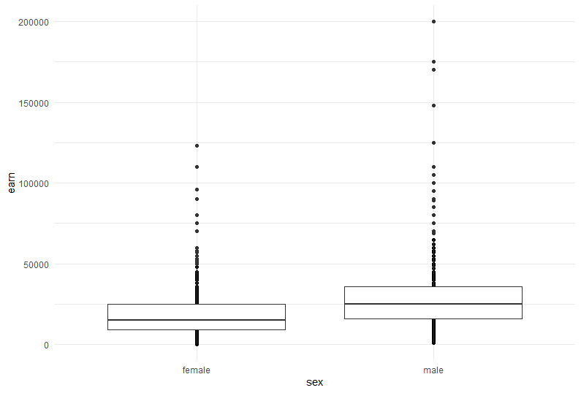

1. **Race Vs Earn**

## race vs. earn

ggplot(heights_df, aes(x=race, y=earn)) + geom_point()+ geom_boxplot()

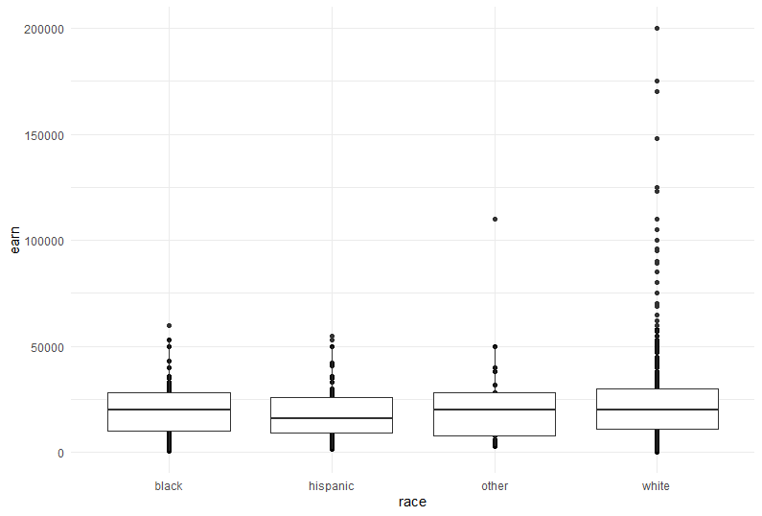

1. **sex-bar-chart**

## `ed` vs. `earn`

## Using `geom_bar()` plot a bar chart of the number of records for each `sex`

ggplot(heights_df, aes(sex)) + geom_bar()

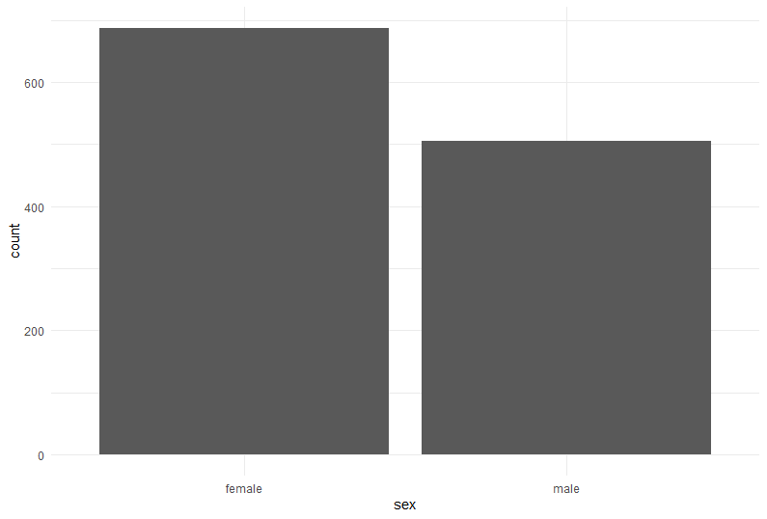

1. **race-bar-chart**

## Using `geom_bar()` plot a bar chart of the number of records for each race

ggplot(heights_df, aes(race)) + geom_bar()

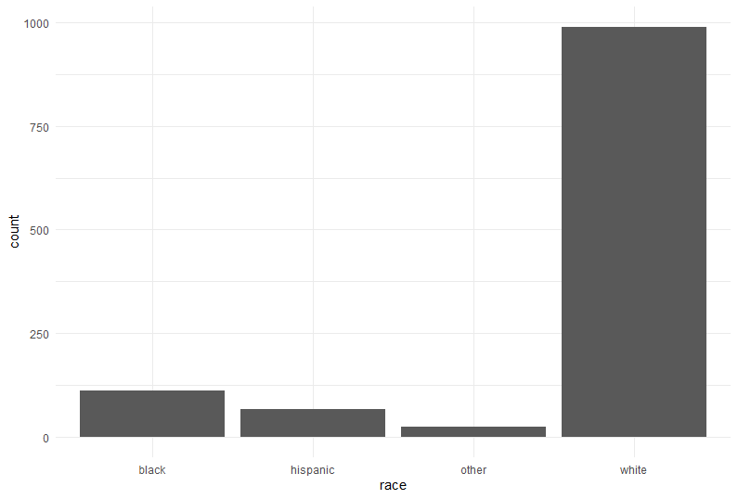

1. **Race-horizontal-bar-chart**

## Create a horizontal bar chart by adding `coord_flip()` to the previous plot

ggplot(heights_df, aes(race)) + geom_bar()+ coord_flip()

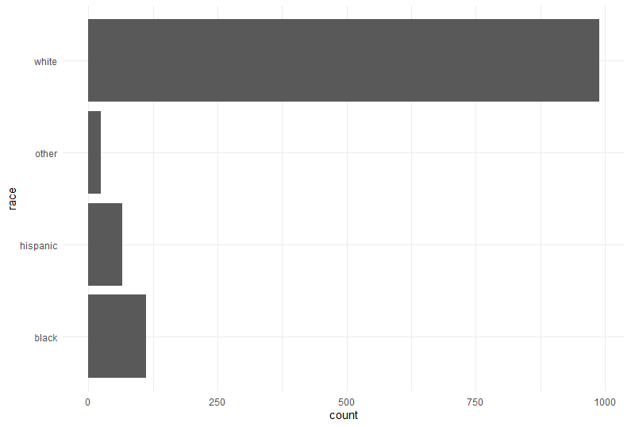

1. **Florida-cases**

covid_df <- read.csv("data/nytimes/covid-19-data/us-states.csv")

## Parse the date column using `as.Date()``

covid_df$date <- as.Date(covid_df$date)

## Create three dataframes named `california_df`, `ny_df`, and `florida_df`

## containing the data from California, New York, and Florida

california_df <- covid_df[ which( covid_df$state == "California"), ]

ny_df <- covid_df[ which( covid_df$state == "New York"), ]

florida_df <- covid_df[ which( covid_df$state == "Florida"), ]

## Plot the number of cases in Florida using `geom_line()`

ggplot(data=florida_df, aes(x=date, y=cases, group=1)) + geom_line()

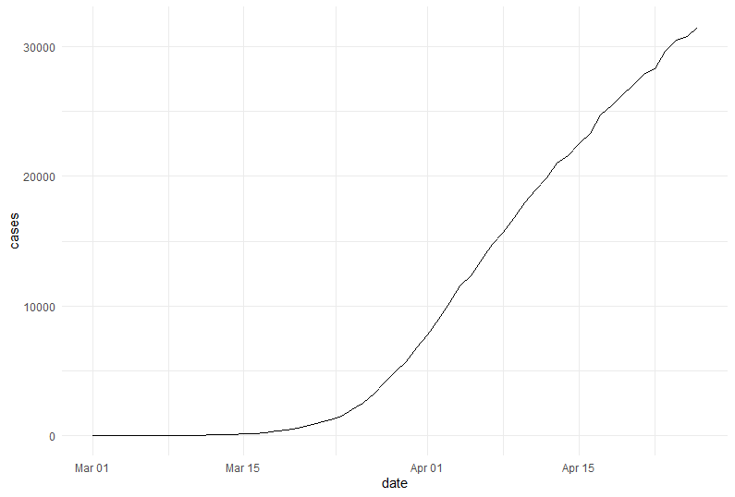

1. **All-cases**

## Add lines for New York and California to the plot

ggplot(data=florida_df, aes(x=date, group=1)) +

geom_line(aes(y = cases)) +

geom_line(data=ny_df, aes(y = cases)) +

geom_line(data=california_df, aes(y = cases))

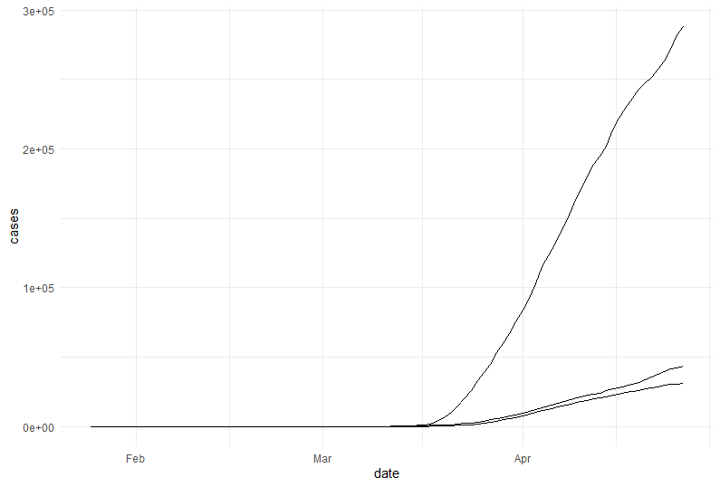

1. **All-cases-color**

## Use the colors "darkred", "darkgreen", and "steelblue" for Florida, New York, and California

ggplot(data=florida_df, aes(x=date, group=1)) +

geom_line(aes(y = cases), color = "darkred") +

geom_line(data=ny_df, aes(y = cases), color="darkgreen") +

geom_line(data=california_df, aes(y = cases), color="steelblue")

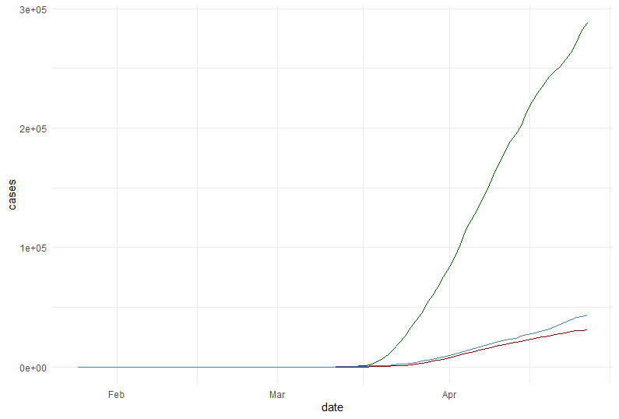

1. **All-cases-legend**

## Add a legend to the plot using `scale_colour_manual`

## Add a blank (" ") label to the x-axis and the label "Cases" to the y axis

ggplot(data=florida_df, aes(x=date, group=1)) +

geom_line(aes(y = cases, colour = "Florida")) +

geom_line(data=ny_df, aes(y = cases,colour="New York")) +

geom_line(data=california_df, aes(y = cases, colour="California")) +

scale_colour_manual("",

breaks = c("Florida", "New York", "California"),

values = c("darkred","darkgreen", "steelblue" )) +

xlab(" ") + ylab("Cases")

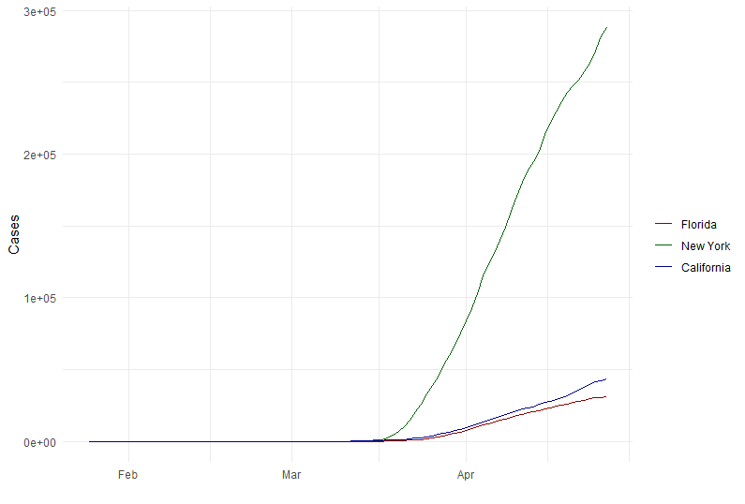

1. **All-cases-log**

## Scale the y axis using `scale_y_log10()`

ggplot(data=florida_df, aes(x=date, group=1)) +

geom_line(aes(y = cases, colour = "Florida")) +

geom_line(data=ny_df, aes(y = cases,colour="New York")) +

geom_line(data=california_df, aes(y = cases, colour="California")) +

scale_colour_manual("",

breaks = c("Florida", "New York", "California"),

values = c("darkred","darkgreen", "steelblue" )) +

xlab(" ") + ylab("Cases") + scale_y_log10()

